Are you looking for a great way to thank your:
* Employee * Co-worker * Teacher * Coach
* Child Care Provider * Pastor * Friend * Family
Chamber Bucks are that perfect gift and can be used in any business in town for gift items, from entertainment to recreation to gas to utility bills and groceries! Chamber Bucks, they’re fast, multipurpose, and convenient for anyone and any age plus ensure your gift is supporting the local economy!
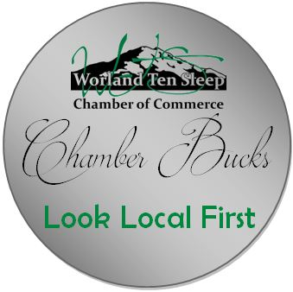

Company Name: ________________________________________ Phone: ____________________________________
Contact Name: _________________________________________ E-mail: _____________________________________
Date Requesting for pickup at Chamber of Commerce: ______________________________

Chamber Bucks come in denominations ($5-$10-$20-$25-$50-$75-$100).
The $5-$100 amounts make it easier to spend than larger Chamber Bucks.

Quantity | $ Amount  ($5-$10-$20-$25-$50-$75-$100) | Sub Total | To: (Optional)
Total:
Method of Payment |  | Cash | Check | Invoice

Thank you for ordering Chamber Bucks to help keep our shopping local!

Please return completed forms to information@wtschamber.org

Worland-Ten Sleep Chamber of Commerce
Office: Suite 208 Monday-Friday 8:30am-5pm
Visitor Site: Suite 120 Monday-Wednesday-Friday 11am-3pm
PO Box 1772
801 Big Horn Ave., Suite 120
Worland, WY 82401
307-347-3226

